*Answers to these DA Conditions:*

*2.2. An Emergency Response Management Plan shall be prepared and submitted to Council's satisfaction. The Plan shall include the following:*

*a) List of chemicals and maximum quantities to be stored at the site;*

*b) Identification of potentially hazardous situations;*

*c) Procedure for incident reporting;*

*d) Details of spill stations and signage;*

*e) Containment and clean-up facilities and procedures; and*

*f) The roles of all staff in the plan and details of staff training.*

*-------------------------------------------------------------------------------------------------------*

1. **LIST OF CHEMICALS**

can be found at [https://labsupply.com.au/chemical-list/](https://protect.checkpoint.com/v2/___https://labsupply.com.au/chemical-list/___.Y3A0YTpjaXR5cGxhbm5pbmd3b3JrczpjOm86NjFjMTZmZDQyMmFkMjFhN2I0YjY4MGZhOTMwYTljYWE6Njo4YTc1OmRhMTA2YjJhN2Q4ZDJhODM1Njc4ZDhiNjVmZGZlN2M3MjQxN2M0MzMzNGY5MDQ3OGYyY2M1OTA0ZmRkMmUyODk6cDpU)

Quantities to be stored on site:

150 x 100g/ml

450x 500g/ml

380 x 2.5L

30 x 20L/kg

b) **IDENTIFICATION of POTENTIALLY HAZARDOUS SITUATIONS with CHEMICALS**

Identifying potentially hazardous situations involving chemicals is crucial for preventing accidents and ensuring workplace safety. Here are some key steps to effectively identify such situations:

1. **Chemical Inventory and Documentation:**
   * A comprehensive inventory of all chemicals used, stored, or handled in the workplace is comprehensively `logged in an Excel file titled Chemicals.xls.
   * Key information about each chemical, including its name, quantity, location, hazards, and safety data sheets (SDS) can be quickly found on the Chemsupply website at chemsupply.com.au
   * .
2. **Hazard Assessment:**
   * Staff need to have knowledge for each category of chemical, considering its properties, toxicity, flammability, reactivity, and potential health and environmental impacts.
   * Use available resources such as SDS, chemical databases, and regulatory guidelines to assess hazards accurately (all available from the Chemsupply website.
3. **Process Analysis:**
   * Evaluate chemical processes and operations to identify potential sources of hazards.
   * Consider factors such as handling procedures, equipment design, storage conditions, and potential interactions between chemicals.
4. **Equipment Inspection:**
   * Staff and management need to regularly inspect and maintain equipment used for handling, storing, or transporting chemicals.
   * Look for signs of wear and tear, leaks, corrosion, malfunctioning safety devices, or other issues that could lead to hazardous situations.
5. **Storage Practices:**
   * Staff and management must ensure proper storage practices for chemicals, including segregation based on compatibility, appropriate containers, labelling, and secondary containment measures.
   * Avoid storing incompatible chemicals together to prevent reactions and hazardous releases.
6. **Safety Data Sheets (SDS):**
   * Review SDS for all chemicals to understand their hazards, safe handling procedures, emergency response protocols, and recommended personal protective equipment (PPE). Overalls, masks, wrist covers, hair nets and shoe covers are always available in stock on request

**c) PROCEDURE for INCIDENT REPORTING-Training/Education:**

Management must:

* + Provide comprehensive training to employees on the hazards associated with chemicals in their work area.
  + Educate employees on how to recognize signs of chemical exposure, leaks, spills, and other potential hazards.
  + Ensure that employees are familiar with emergency response procedures and know how to use safety equipment effectively.
    - 1. **Near-Miss Reporting:**
  + Encourage employees to report near-miss incidents involving chemicals, even if no harm occurred.
  + Investigate near-miss incidents to identify underlying causes and implement corrective actions to prevent future accidents. Such reports to management must be immediate
  + **2 Regulatory Compliance:**

Management must:

* + Stay informed about relevant regulations and standards governing the handling, storage, and disposal of chemicals.
  + Ensure compliance with regulatory requirements and industry best practices to minimize risks and liabilities.
  + **3 Continuous Improvement:**
  + Regularly review and update hazard assessments, safety procedures, and training programs based on new information, emerging hazards, and lessons learned from incidents.
  + Encourage a culture of continuous improvement and proactive risk management to prevent chemical-related accidents and protect personnel, the environment, and assets.

1. **DETAILS OF SPILL STATIONS and SIGNAGE**

A regulation Australian Standard Spill Station is located in the entry aisle #1 in close proximity to the central roller door:

120 Litre Hazchem Spill Kit – AusSpill Quality Compliant This 120 Litre Hazchem Spill Kit meets the AusSpill product quality guidelines and is tested to BS5979 to ensure genuine absorbent capacity. The station comprises:

|  |  |
| --- | --- |
| 100 | Hazchem Absorbent Pad – 480 x 430mm |
| 3 | Hazchem Absorbent Boom – 1.2m x 75mm |
| 1 | Hazchem Absorbent Boom – 3m x 75mm |
| 2 | Hazchem Absorbent Sweep – 14L Bag |
| 2 | Hazchem Absorbent Pillow – 450 x 450mm |
| 5 | Contaminated Waste Bags & Ties |
| 1 Pair | Nitrile Gloves |
| 1 | Tamper Evident Spill Kit Audit Tag |
| 1 | Clear PVC Spill Kit Cover |
| 1 | Laminated Instruction Sheet |
| 1 | Lime Green Bin With Yellow Lid – 140L |

**e) CONTAINMENT and CLEAN-UP FACILITIES and PROCEDURES to be IMPLEMENTED by all MANAGEMENT and STAFF**

* + 1. **Containment**: Proper containment of chemicals involves storing them in appropriate containers designed to withstand the chemical's properties. This includes using containers made of materials resistant to corrosion or degradation by the chemicals stored within them. Additionally, containers should be labeled clearly with the name of the chemical, its hazards, and any special handling instructions.
    2. **Secondary Containment**: Especially in environments where spills are more likely, such as laboratories or industrial facilities, secondary containment measures should be in place. This involves placing chemical storage containers within secondary containment trays or bunds to contain spills and prevent them from spreading to the surrounding area.
    3. **Personal Protective Equipment (PPE)**: Workers handling chemicals should wear appropriate PPE, including gloves, goggles, aprons, and respirators as necessary, to protect themselves from exposure to hazardous substances.
    4. **Spill Response Plan**: Establishing a spill response plan is essential. This plan should include procedures for containing and cleaning up spills, as well as protocols for evacuating the area if necessary. All personnel should be trained in spill response procedures and know how to use spill response equipment effectively.
    5. **Spill Clean-up Kits**: Having spill clean-up kits readily available in areas where chemicals are stored or used is important. These kits typically include absorbent materials such as spill pads, socks, or granules, as well as personal protective equipment and tools for containing and cleaning up spills.

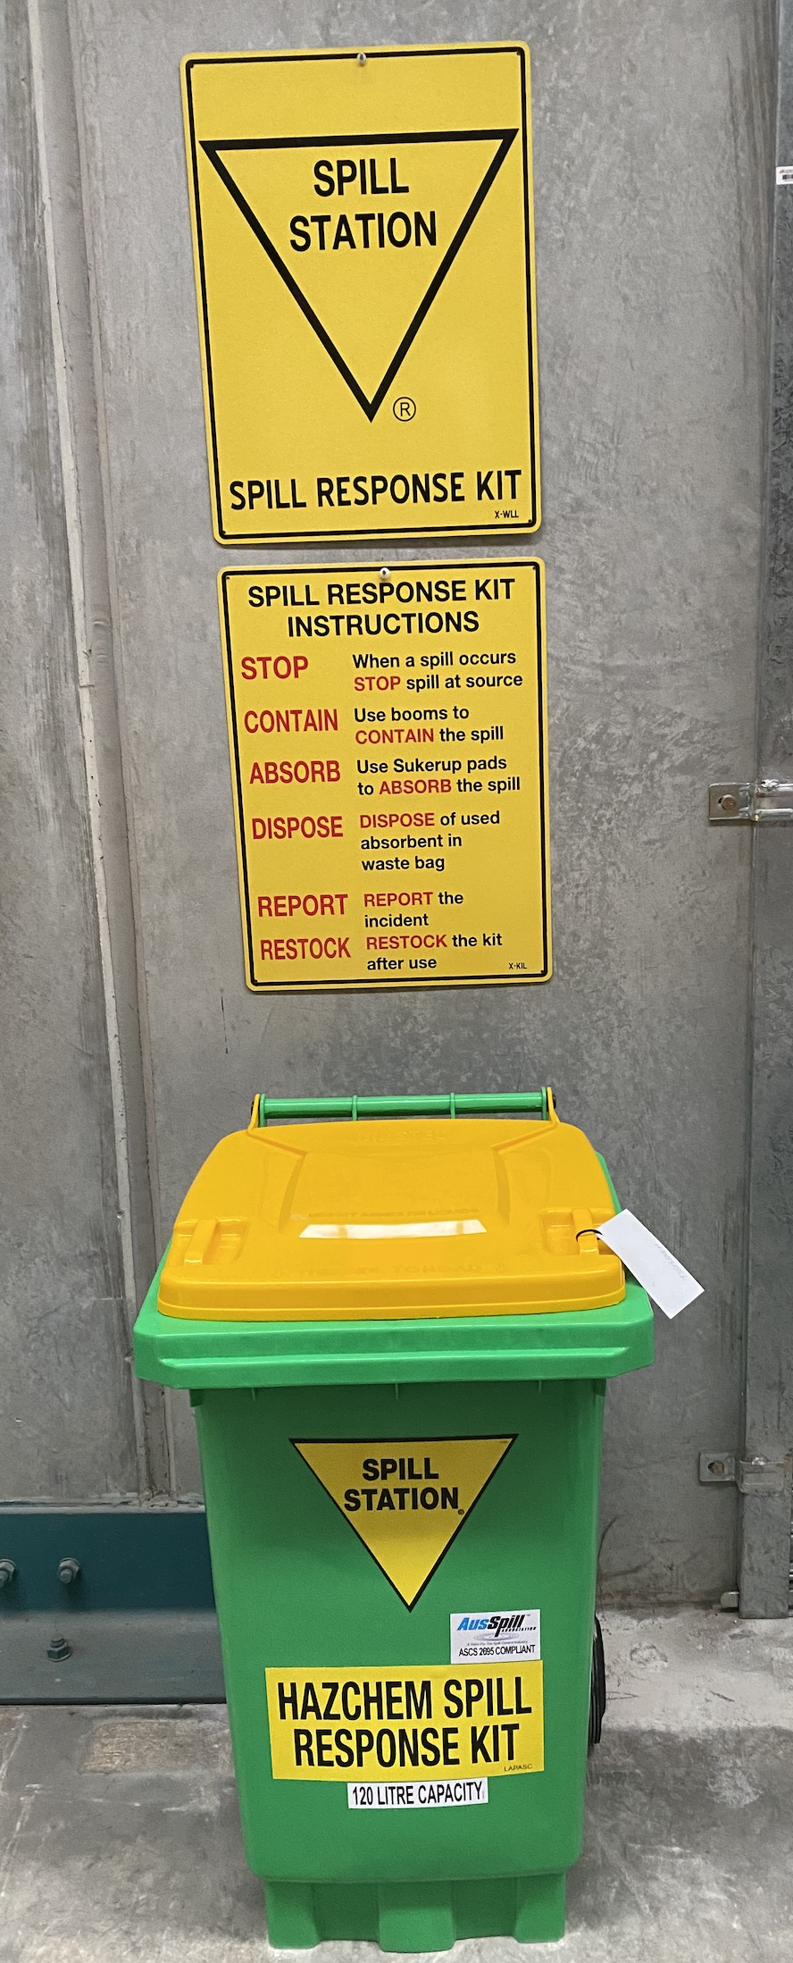 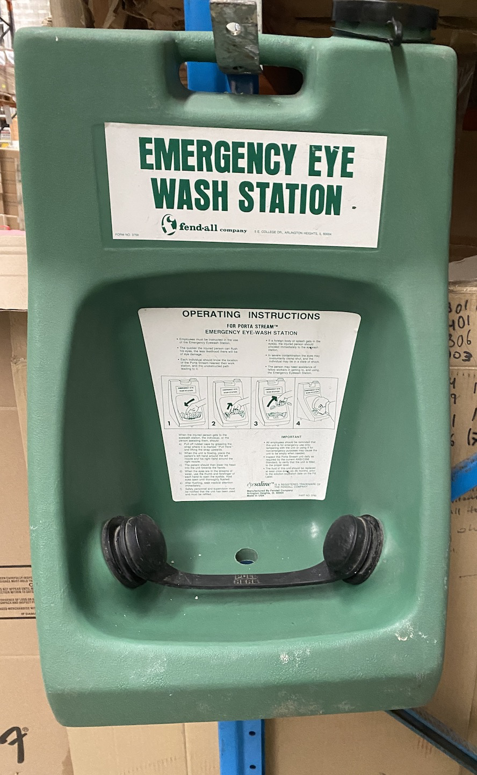

* + 1. **Proper Ventilation**: Adequate ventilation is crucial in areas where chemicals are stored or handled to prevent the buildup of hazardous fumes or vapors. This may involve the installation of local exhaust systems or general ventilation systems to remove airborne contaminants from the work area.
    2. **Neutralization**: Some chemicals may require neutralization before clean-up to reduce their hazardous properties. However, this should only be done by trained personnel following appropriate procedures and using compatible neutralizing agents.
    3. **Waste Disposal**: Proper disposal of contaminated materials is essential to prevent environmental contamination. Contaminated materials should be collected and disposed of according to local regulations and guidelines for hazardous waste management.
    4. **Emergency Response**: In the event of a large-scale chemical spill or emergency, having access to emergency response teams and resources is crucial. Establishing communication protocols with local emergency responders and having access to specialized clean-up equipment can help mitigate the impact of chemical accidents.

**f) THE ROLES of STAFF in the PLAN and DETAILS of STAFF TRAINING**

* + 1. By systematically identifying potential hazards associated with chemicals and implementing appropriate controls and preventive measures, our organization can minimize risks and create safer work environments. All personnel working with chemicals will receive comprehensive training on safe handling procedures, including containment and clean-up protocols. Regular refresher training sessions will be conducted to ensure that employees remain knowledgeable and proficient in handling hazardous materials safely.

Top of Form

Bottom of Form